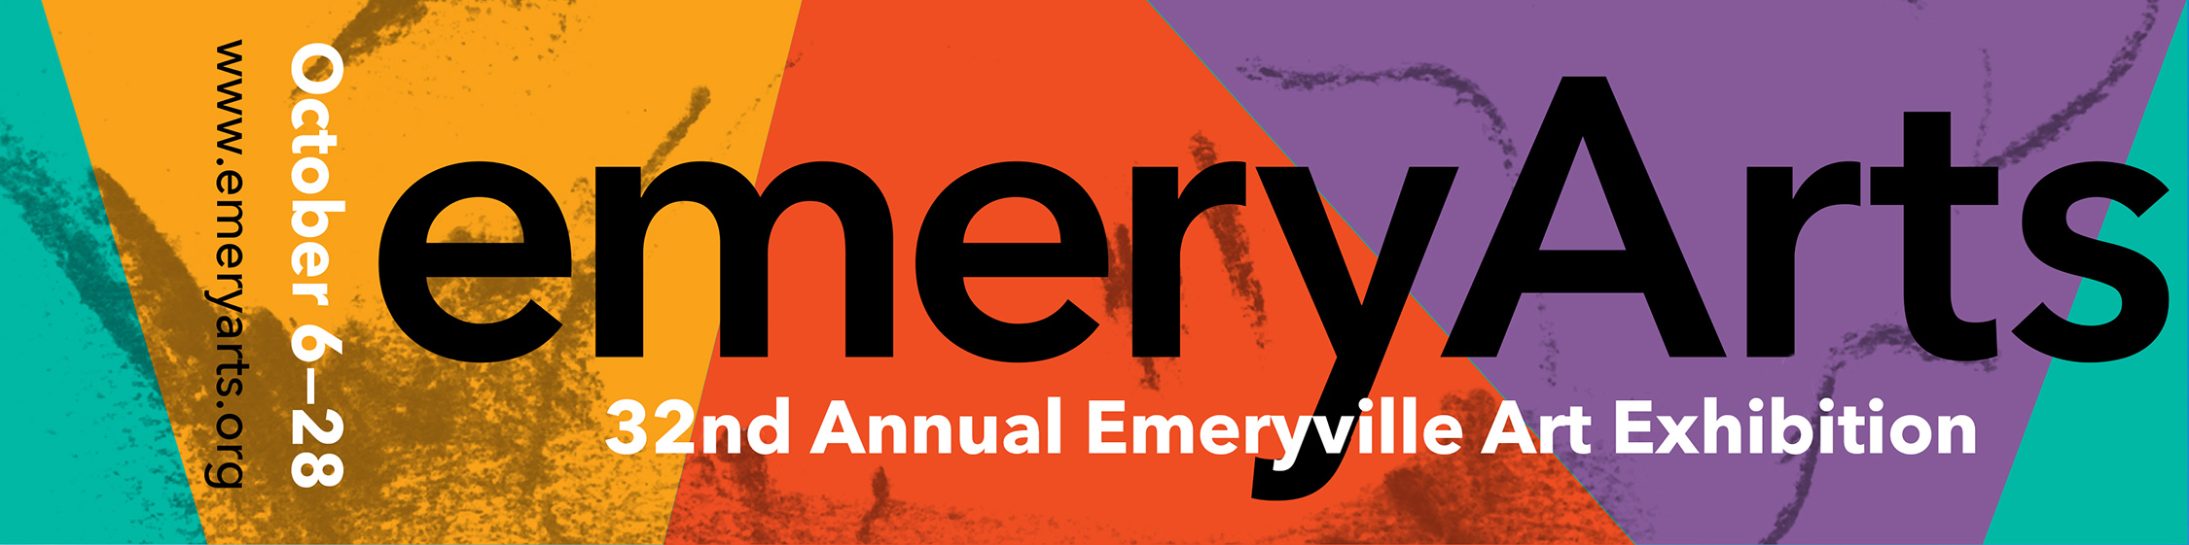
MEDIA CONTACT:
Genevieve Antaky, 510/435-8092
gantaky@comcast.net
PUBLIC INFO: 510/652-6122 or
www.emeryarts.org

EMERYVILLE CELEBRATION OF THE ARTS ANNOUNCES THE LOCATION OF
32nd ANNUAL EMERYVILLE ART EXHIBITION
5700 HORTON STREET
Emeryville, CA
On Display October 6 - 28, 2018
Opening Reception, 6-9pm, Friday, October 5, 2018

FOR IMMEDIATE RELEASE: (EMERYVILLE, CA, September 19, 2018)
Emeryville Celebration of the Arts, Inc., is pleased to announce the location of the 32nd Annual Emeryville Art Exhibition at 5700 Horton Street in Emeryville. The annual juried show is held at a different location each year – generously donated by a local Emeryville business. East Bay Therapeutics and East Bay Drone Zone have donated the space for the 2018 Exhibition, on display October 6 through October 28, 2018, open daily from 11 am to 6 pm, with free admission. There will be a gala public reception with the artists in attendance on Friday, October 5, from 6 pm to 9 pm, with live music by The doRiaN Mode: Vintage Jazz & Blues. A no-host bar will raise funds for the Emeryville Youth Art Program. For directions and emery-go-round stop, log on to: www.emeryarts.org or call 510/652-6122.

The 32nd Annual Emeryville Art Exhibition celebrates the work of Emeryville artists and includes paintings, sculpture, photographs, prints, textiles, ceramics, glass works and poetry. The sheer number and array of artists living or working in Emeryville illustrates the city's cultural vibrancy and provides an impressive creative pool that continues to create new and exciting works. The 2018 exhibition features 165 works from 115 artists, representing the largest group show in its 32-year history. The individual pieces demonstrate the diversity of Emeryville artists and show their engagement with a host of aesthetic, political, and social concerns. A panel of Bay Area arts professionals selected the collection of artwork for the exhibition. Independent curator and exhibition designer Kathleen Hanna has served as curator and juror for eight years. The other 2018 jurors are Tim Buckwalter, director of exhibitions, NIAD Art Center, Richmond and Ruth Santee, co-director/owner of Transmission Gallery, Oakland.

“For thirty-two years the Emeryville Celebration of the Arts has been a catalyst sparking a truly community event inspiring new and returning artists to create specific works and stimulating community support for their efforts,” said Kathleen Hanna. “This year, the record 165 works represent a community as lively and talented as it is diverse.”

Contributing artists include conceptual artist Packard Jennings, painters Sienna Ko, Jerry Smith, M. Louise Stanley and Jesse Walton, sculptors Cheryl Coon, Mark Galt, Ken Kalman and Melody Kozma-Kennedy, ceramic artists Jered Nelson and Sara Paloma, printmakers Linda Lee Boyd, Erin Fong, Nora Pauwels and Kazuko Watanabe, jewelers Ruth Rhoten and Renée Willis, and textile artist Susan Taber Avila. Works on exhibit are for sale.

Along with the dynamic collection of visual art, the 2018 Annual Emeryville Art Exhibition will also host a poetry writing workshop and a special poetry reading led by Emeryville’s former Poet Laureate, Sarah Kobrinsky. The poetry reading takes place at 2 pm on Sunday, October 21 in the exhibition gallery and admission is free. Acclaimed Bay Area poets Terry Lucas, Rohan DaCosta, and Maw Shein Win will join Kobrinsky to read their poems inspired by works in the exhibition. For details about the poetry reading and workshop visit www.emeryarts.org.

“The city of Emeryville is home to a treasure trove of talented artists and creatives,” said Ruth Santee, juror for the 2018 exhibition. “Diverse in who they are and what they do, all unite in their support for this annual celebration. Once again this mutually beneficial event will undoubtedly be a success creating an amazing symbiosis between city and art.”
“The Bay Area’s cultural industries are facing crucial challenges: with the tech boom and gentrification, artists are being forced out of their spaces and small galleries are closing,” explained juror Tim Buckwalter. “But, what is overlooked in this conversation about loss, is the vibrant and lively art community in Emeryville. This city continues to be a safe haven for the arts and artists, and this year’s celebration spotlights that remarkable achievement.”

Emeryville is designated by the California Arts Council as one of only 14 cities across the state that serve as premier Cultural Districts, highlighting thriving cultural diversity and unique artistic identities. The Annual Emeryville Art Exhibition serves as a celebration of the city’s thriving collective creativity and an invitation for community members and visitors to experience a sampling of artwork created by Emeryville artists.

The mission of the non-profit Emeryville Celebration of the Arts, Inc. is to foster an appreciation of the arts and artists of Emeryville, and to promote the city as a culturally vital and progressive center for living and working. The Annual Emeryville Art Exhibition continues to support this mission by providing a free public venue, open to all, to experience the rich diversity of artistic expression of those who live and work within the city of Emeryville.

CALENDAR LISTING - ART EXHIBITS:
What: Annual Emeryville Art Exhibition –
Celebrating Art & Artists in Emeryville
Group show featuring the works of 115 artists and craftspeople that live or work in Emeryville. The exhibition is open to artists of all media and includes paintings, sculpture, photographs, ceramics, textiles, glass works, and poetry. Juried by a panel of arts professionals, the annual exhibition continues to uncover emerging talent along with new work by established artists.

The Annual Emeryville Art Exhibition is sponsored by Emeryville Celebration of the Arts, Inc.. Independent curator and exhibition designer Kathleen Hanna is curator and juror. The other 2018 jurors are Tim Buckwalter, director of exhibitions, NIAD Art Center, Richmond and Ruth Santee, co-director/owner of Transmission Gallery, Oakland.

The site for the 32nd Annual Emeryville Art Exhibition has been generously donated by East Bay Therapeutics and East Bay Drone Zone.

When: 32nd Annual Emeryville Art Exhibition is open daily
11am-6pm, October 6 - 28, 2018

Opening Reception: 6-9pm, Friday, October 5, 2018

Cost: FREE Admission to the Exhibition and Opening Reception

Location: 5700 Horton Street, Emeryville, CA

Info: www.emeryarts.org or call 510/652-6122

CALENDAR LISTING – ART OPENINGS/BENEFITS:
What: Opening Reception for the Annual Emeryville Art Exhibition -
Celebrate art in Emeryville. Meet the artists and get a sneak-peek of the collection on display at Emeryville Celebration of the Arts’ 32nd Annual Art Exhibition - a juried show featuring works of 115 artists and craftspeople who live or work in Emeryville. Live music is provided by The doRiaN Mode: Vintage Jazz & Blues.

A no-host bar will raise funds for the Emeryville Youth Art Program, which brings professional artists into Emeryville public schools.

When: Opening Reception, 6-9pm, Friday, October 5, 2018
The exhibition is open daily 11am-6pm, October 6- 28, 2018

Cost: FREE Admission to the Reception
Proceeds from the no-host bar benefit Emeryville Youth Art Program

Location: 5700 Horton Street, Emeryville, CA

Info: www.emeryarts.org or call 510/652-6122

###

